Exp. No: 1
Date:
Transformation between Cartesian, Cylindrical and spherical coordinate system
Aim:
To write program for Transformation between Cartesian, Cylindrical and spherical coordinate system using SCILAB.
Software required:
- SCILAB version 6.0.1
Program:
Test case (i) Transformation of Cartesian coordinate points in to Cylindrical and spherical coordinate system
Program:
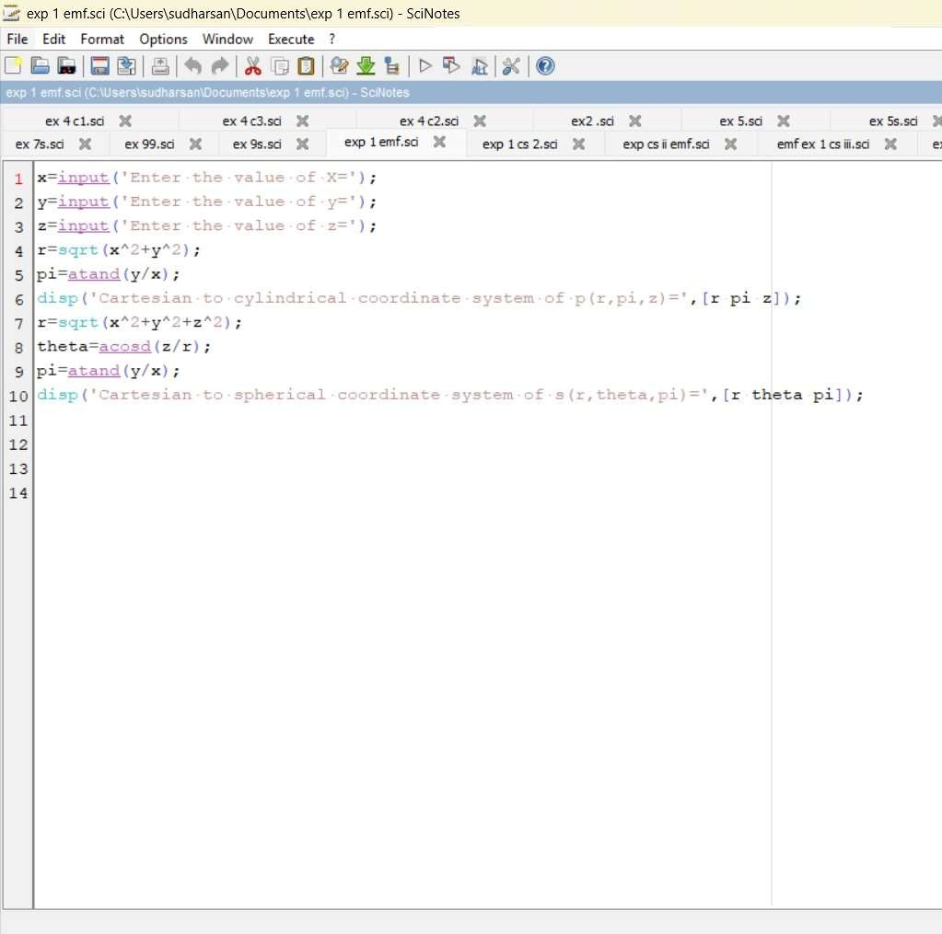
Output:

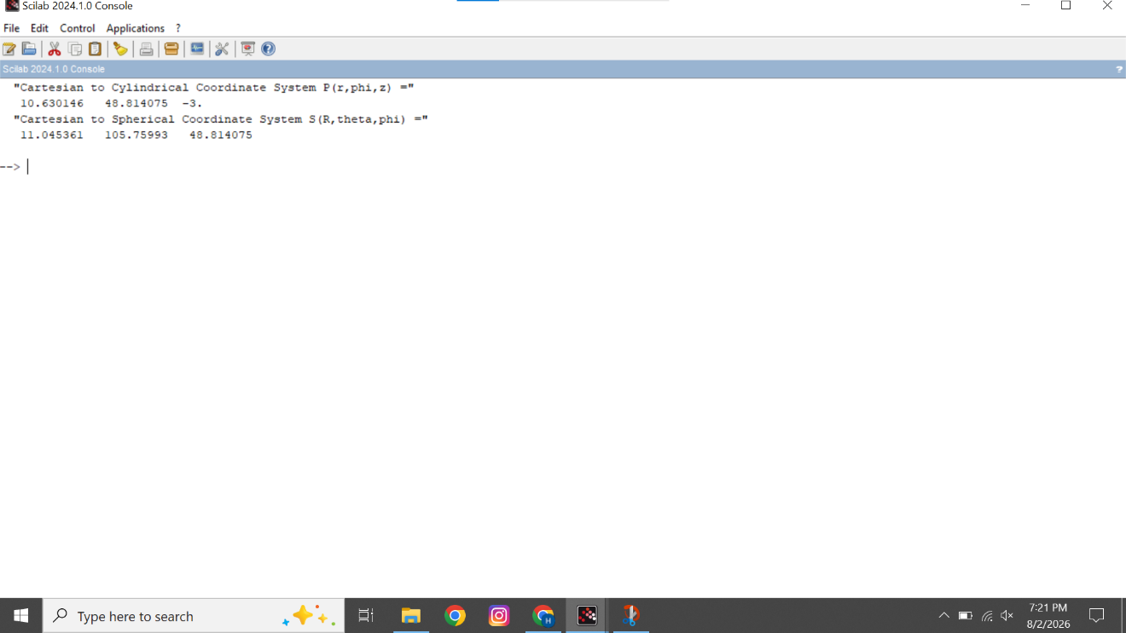

Calculation:
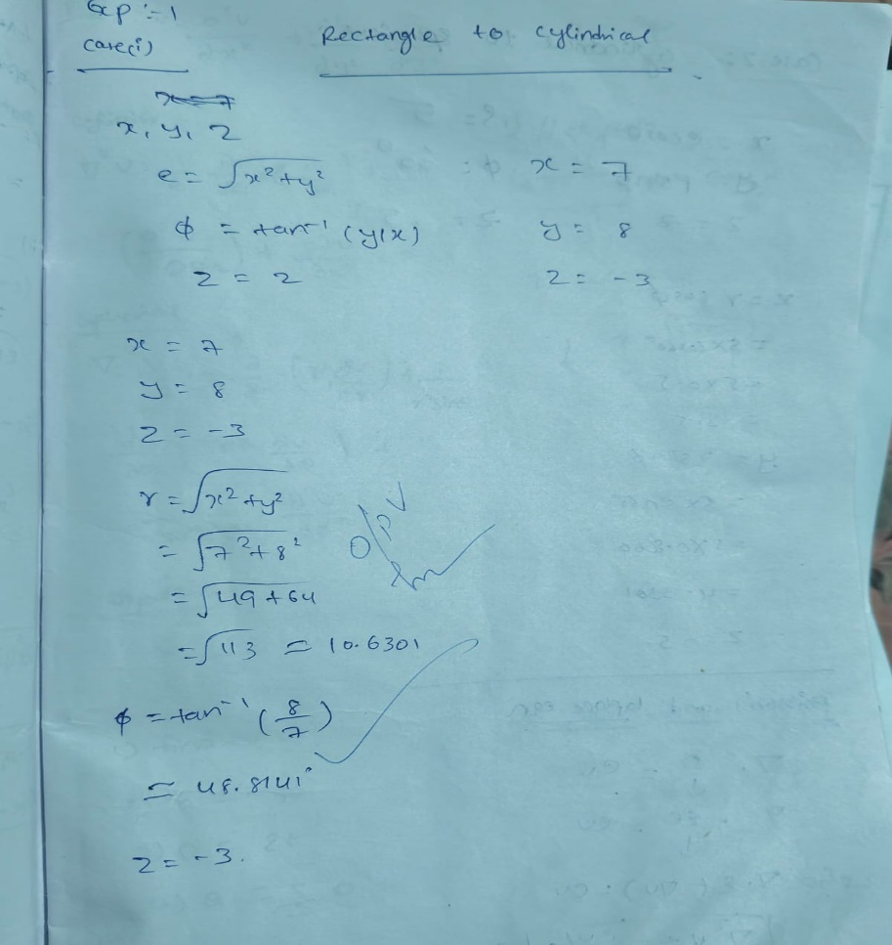

Test case (ii) Transformation of Cylindrical coordinate points into Cartesian and spherical coordinate system.

Program:
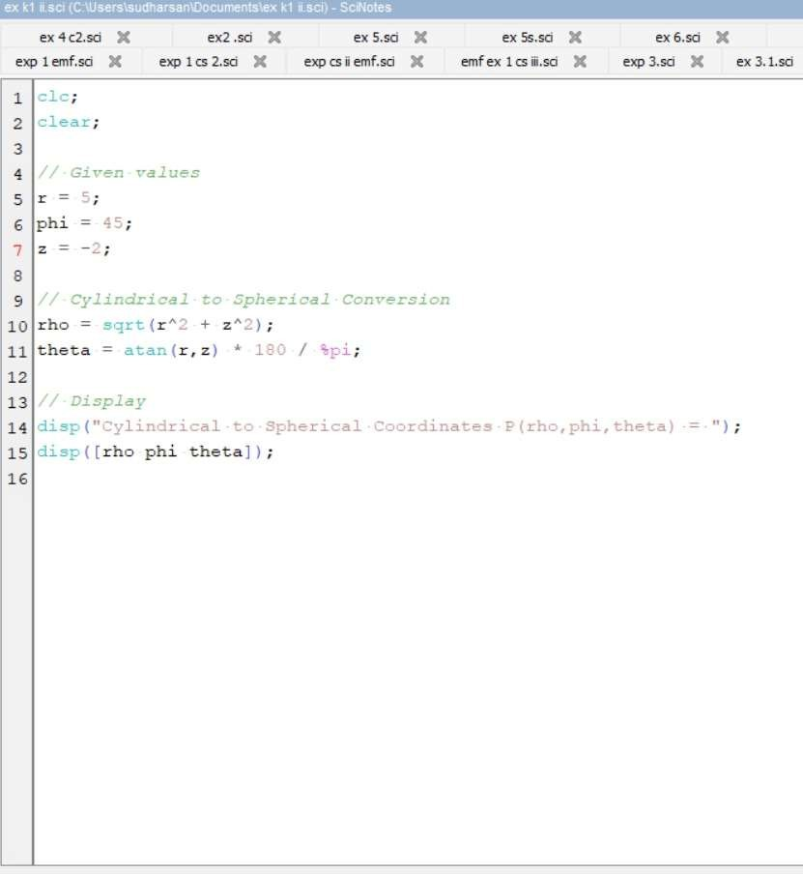

Output:-

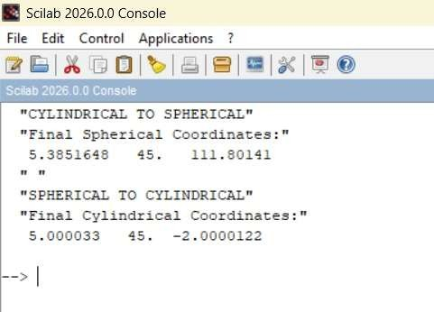

Calculation:
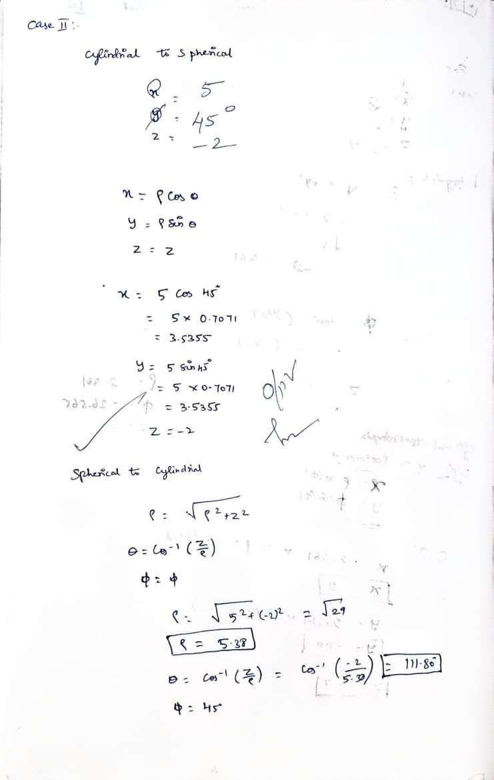

Test case (iii) Transformation of spherical coordinate points into Cylindrical and Cartesian coordinate system

Program:

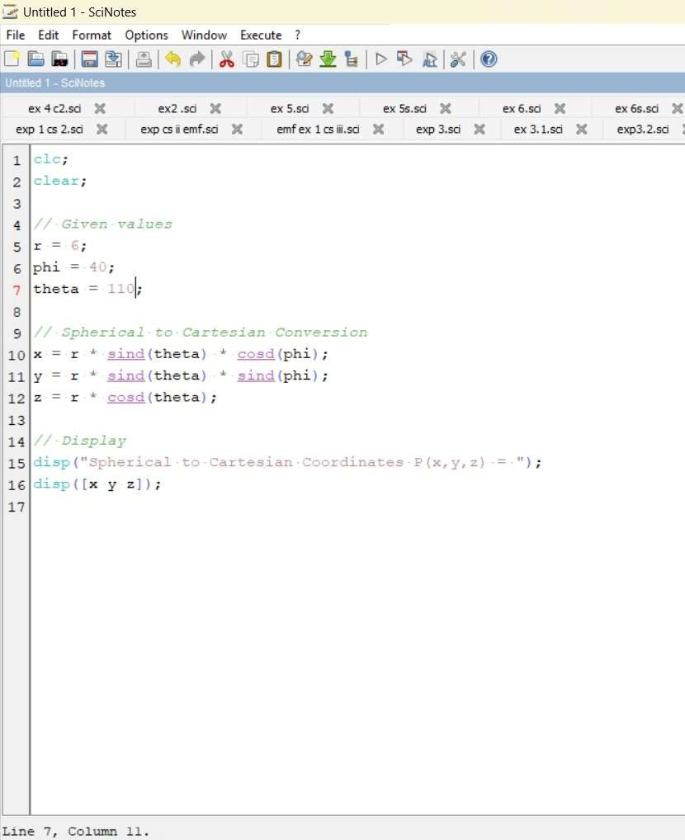
Output:-

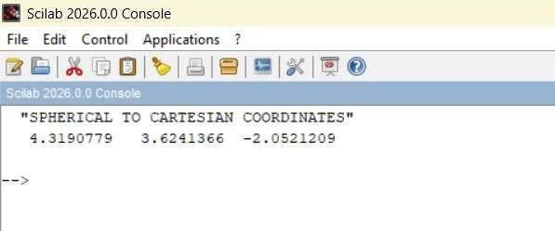

Calculation:

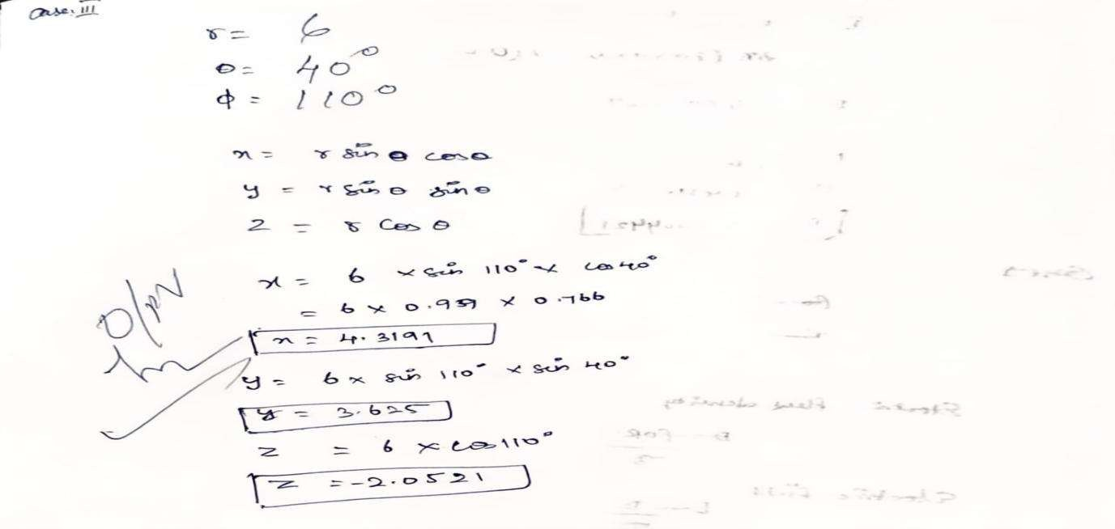
Result:
Thus, the program was verified Transformation between Cartesian and Cylindrical coordinate system its classified two categories (a) Cartesian to cylindrical and spherical coordinate system (b) Cylindrical to cartesian and spherical coordinate system (c) spherical to cartesian and cylindrical coordinate system using SCILAB was successfully.

